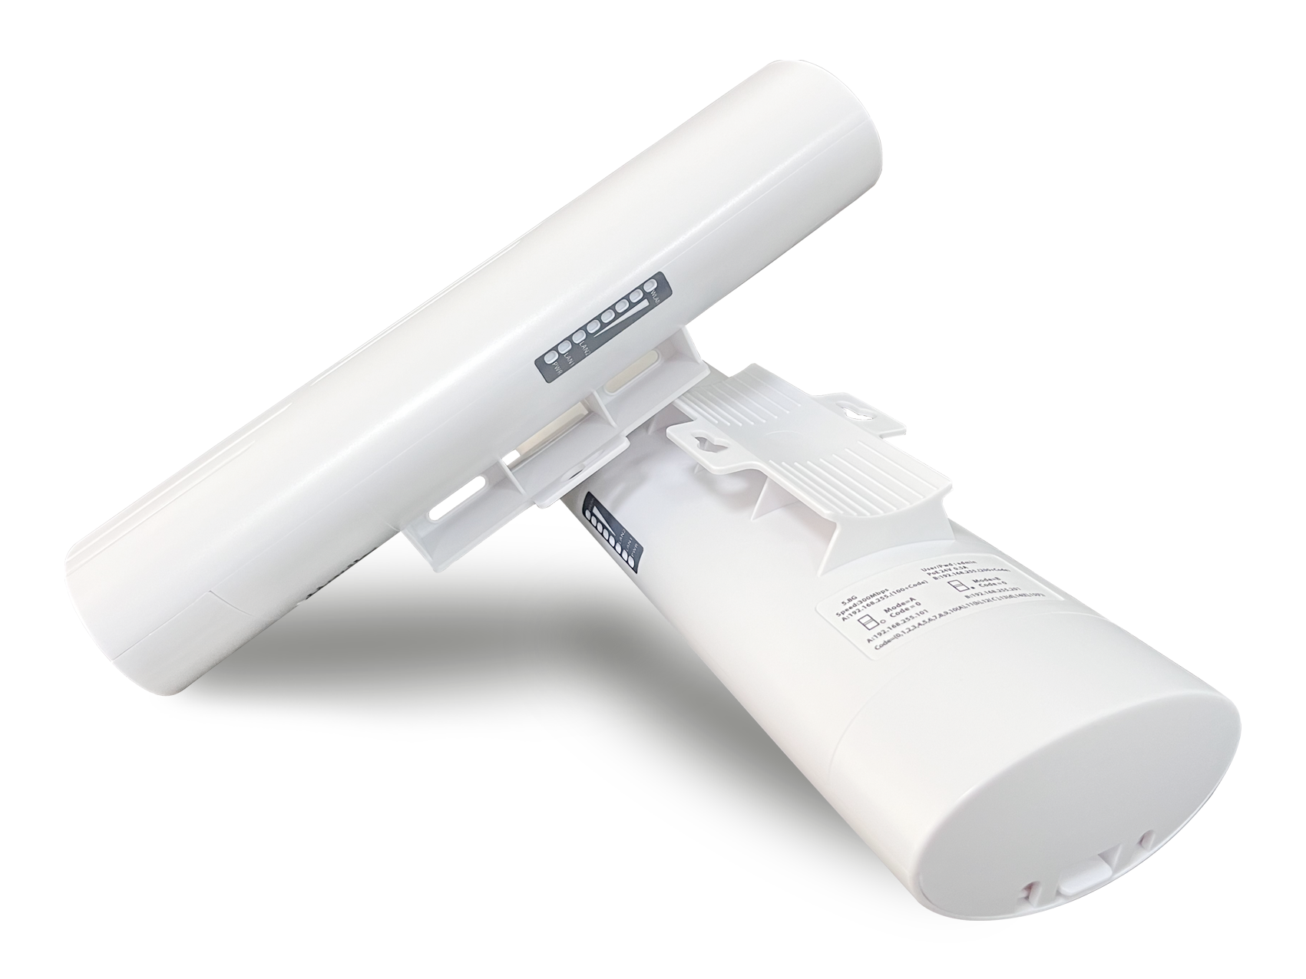
Product Features
- Supports peer-to-peer and point-to-multipoint bridging, offering flexible applications to meet diverse use cases.
- 5.8 GHz frequency band, supports spread spectrum technology with a maximum wireless transmission rate of 300 Mbps;
- Exhibits strong anti-interference capability, remains unaffected by external environmental factors, and ensures stable transmission;
- Equipped with Qualcomm's engineering-grade chips from the United States, delivering stable and reliable performance.
- Featuring an external high-power PA circuit design and a built-in high-gain directional antenna, it delivers strong signal strength and extended transmission range.
- Supports automatic restart, reduces system operation cache, optimizes system performance, and ensures smooth long-term device operation.
- Supports hiding the bridging SSID from wireless signals to prevent wireless devices from detecting it, protect network data from malicious attacks, and ensure user data security.
- Supports both 24V PoE and 12V DC power supplies with plug-and-play functionality for flexible power sourcing.
- Featuring an outdoor rain-resistant design with IP65 protection rating, it is resistant to rain, dust, wind, and sunlight, effortlessly adapting to various harsh outdoor conditions while ensuring long-term stable operation.
- With an olive-shaped design that is simple yet elegant, it's easy to install and can be mounted either wall-mounted or on a bracket.
- Suitable for various outdoor application scenarios, including construction site monitoring, tower crane monitoring, scenic area monitoring, elevator monitoring, factory premises monitoring, port monitoring, residential community monitoring, and outdoor network transmission.

Product Specifications
Product Name | 5.8G Wireless Bridge
Product Model | WB5830H
Hardware Specifications
Hardware System | Main Chip | AR9344
Hardware System | internal storage | 64MB
Hardware System | FLASH | 8MB
Wireless Parameters | protocol standard | IEEE 802.11a/n
Wireless Parameters | Working Frequency Band | 5.8G：5180MHz ~5825MHz
Wireless Parameters | Wireless Speed | 300Mbps
Wireless Parameters | transmitting power | 20dBm
Physical Interface | network interface | Two 10/100 Mbps Ethernet ports (both support 24V PoE power supply)
Physical Interface | Hardware Button | 1 RESET button
Wireless Type | Wireless Type | Built-in 14 dBi bipolar directional antenna
Pilot Lamp | LED pilot lamp | In order: POWER, WAN/LAN, WAN/LAN, four signal lights, WIFI
Power Supply/Power Consumption | power supply mode | 24V PoE power supply
Power Supply/Power Consumption | Total Power of the Device | ﹤6W
Product Accessories | main engine | 5.8G Wireless Bridge Host *1
Product Accessories | Power Adapter | 24V 0.5A PoE power supply
Product Accessories | else | Stainless steel clamp *1  User Manual *1  Qualification Certificate *1
Appearance/Packaging/Weight | Appearance Color | white
Appearance/Packaging/Weight | product size | 250mm*90mm*60m
Appearance/Packaging/Weight | packing measurement | 295 mm × 283 mm × 82 cm (set of two)
Appearance/Packaging/Weight | weight | 2.1 kg (per pack)
Appearance/Packaging/Weight | carton size | 58.3*30.8*43.8cm
Appearance/Packaging/Weight | packing quantity | 20 pieces per box
Appearance/Packaging/Weight | net weight | 21kg
Appearance/Packaging/Weight | rough weight | 22.5kg
Else | The optimal power supply distance for a PoE network cable | Within 65 meters (using Category 5e or higher network cables)
Else | Bridge Distance | 0–1.5 km
Else | IPC Load Capacity | Route 15: No lag, no delay
Else | way to install | Rod mounting, Wall-mounted installation, Support bracket installation
Else | levels of protection | IP65 rating; 2 kV lightning protection
Software Specifications
Network | work pattern | Wireless bridge, wireless router, wireless AP, wireless terminal, wireless repeater
Network | WAN Access Method | PPoS-PoE dialing, dynamic acquisition, fixed IP
Network | MAC Address Binding | support
Network | Up and Down Rate Display | support
Network | LAN Configuration | support
Network | DHCP server | support
Wireless Settings | Wireless Channel Modification | Support, support spread spectrum
Wireless Settings | Bandwidth Settings | support
Wireless Settings | SSID hide | support
Wireless Settings | Wireless Power Regulation | support
Wireless Settings | User Isolation | support
Wireless Settings | user management | support
Wireless Settings | multi SSID | support
Wireless Settings | way of encryption | WPA2-PSK
Wireless Settings | Up and Down Rate Display | support
System | Web Interface Configuration | support
System | SL | Supports Chinese/English
System | Change Management Password | support
System | firmware upgrade | support
System | Firmware File Import and Export | support

Interface Specification
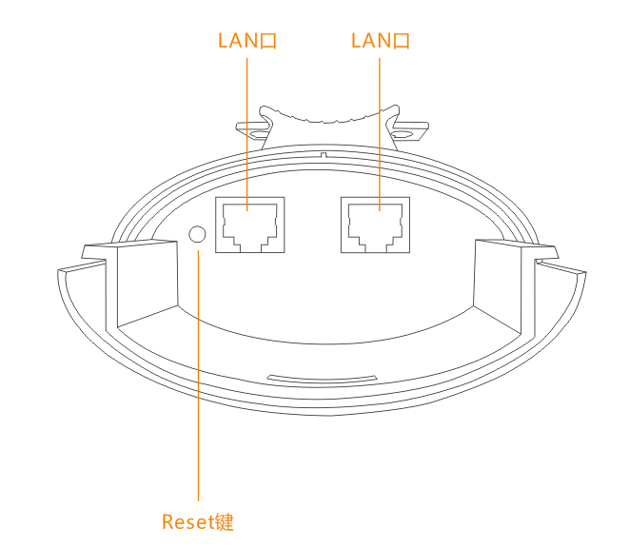
Product Size
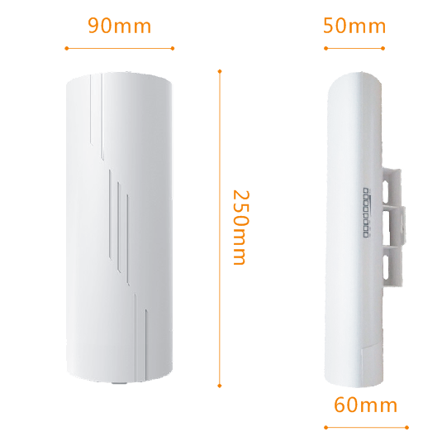

Product Application
I. Point-to-point wireless monitoring transmission applications 1

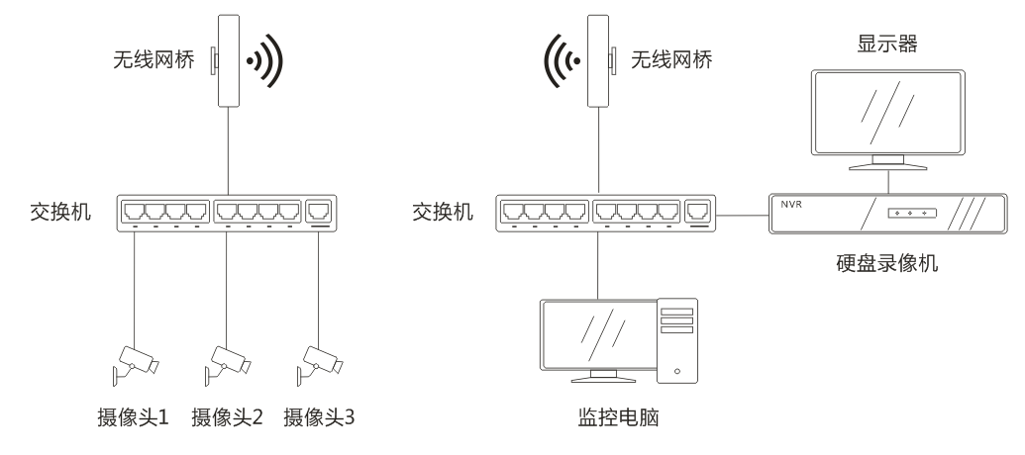

II. Point-to-point wireless monitoring transmission applications 2

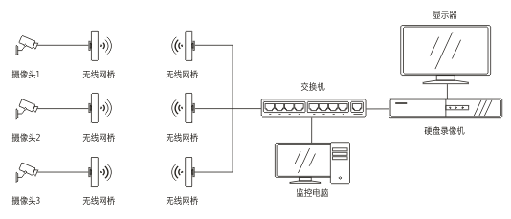

III. Wireless Monitoring Transmission: Point-to-Multipoint Applications 3

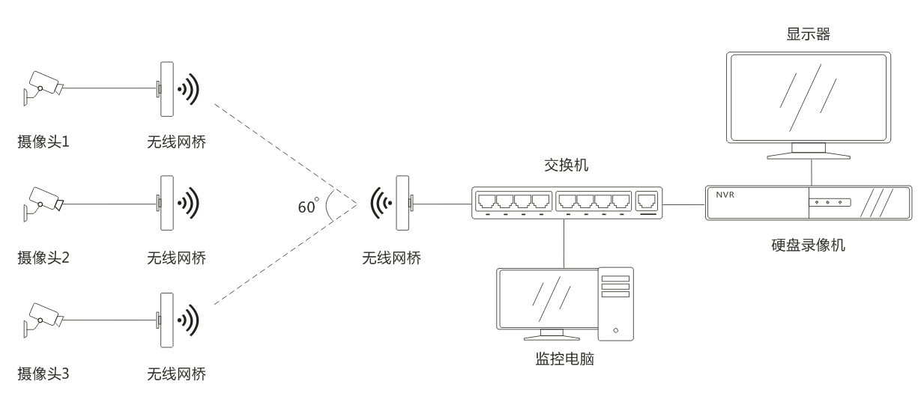

IV. Internet of Things Data Transmission Applications

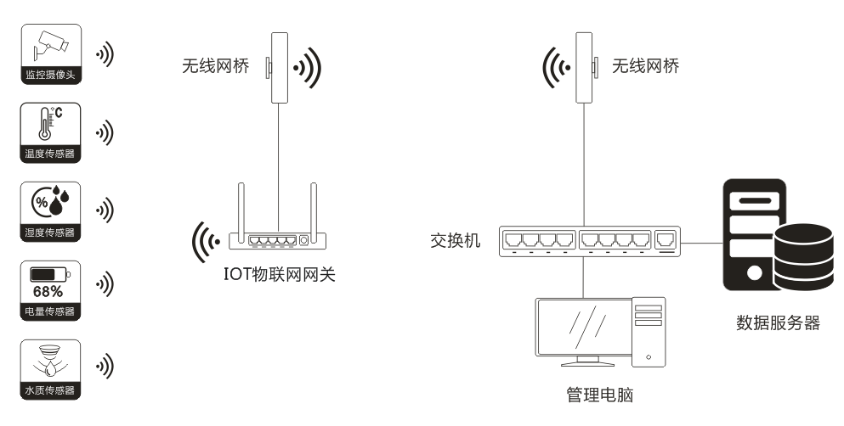

V. Applications of Wireless Data Transmission over the Internet 1

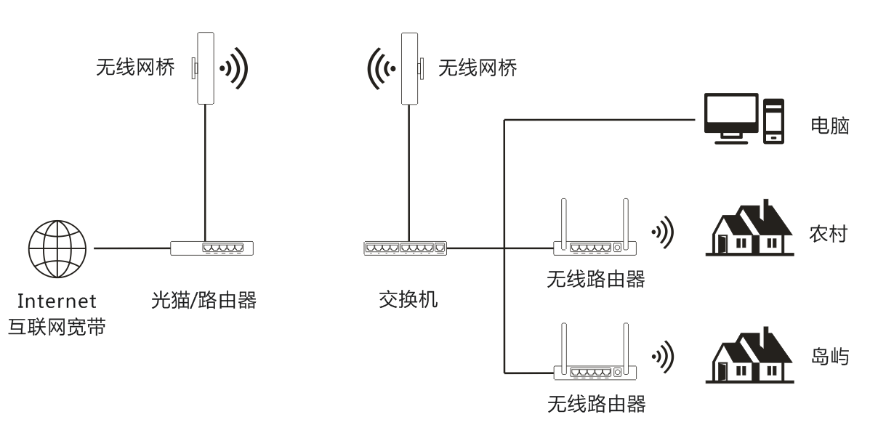

VI. Internet Wireless Transmission Applications 2
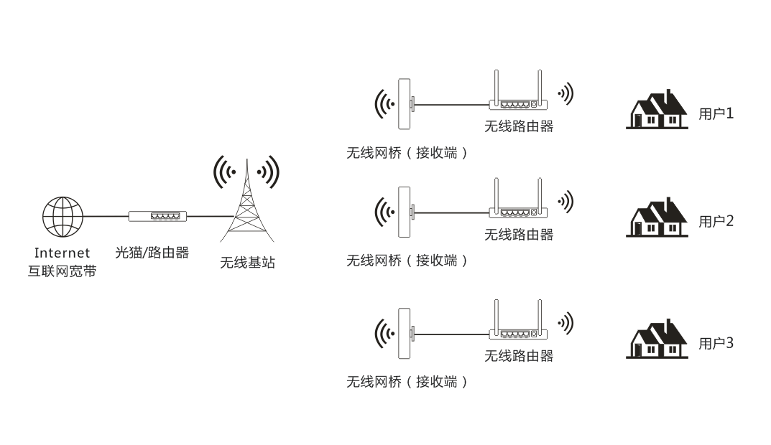

VII. Internet Coverage Applications 3

